**Computed Torque Controller**

The computed torque controller is appplied to a two-docked holonomic mobile robot. The controller is designed such that the leader tracks spline function. The wheels’ input torques are calculated using follwing formulation:

The equation of the motion of the robots

$$M\left(q\right)\ddot{q}+V\left(q,\dot{q}\right)=B(q)τ$$

So the wheels’ input torques will be

${τ=B(q)}^{-1}M\left(q\right)\ddot{q}+{B(q)}^{-1}V\left(q,\dot{q}\right)$ + ${B(q)}^{-1} (k_{p}e+k_{d}\dot{e})$

To set up the controller, we can adjust:

1. Saturation limit of the integrator inside the two-robots’ dynamic
2. $k_{p}$ and $k_{d}$ coefficients

The differential solve should be done using fixed step of ode4 (Runge-kutta).

The ripple that can be seen in the figures are arising from solving the equation discretely. We can filter them out if we want to cancel them.

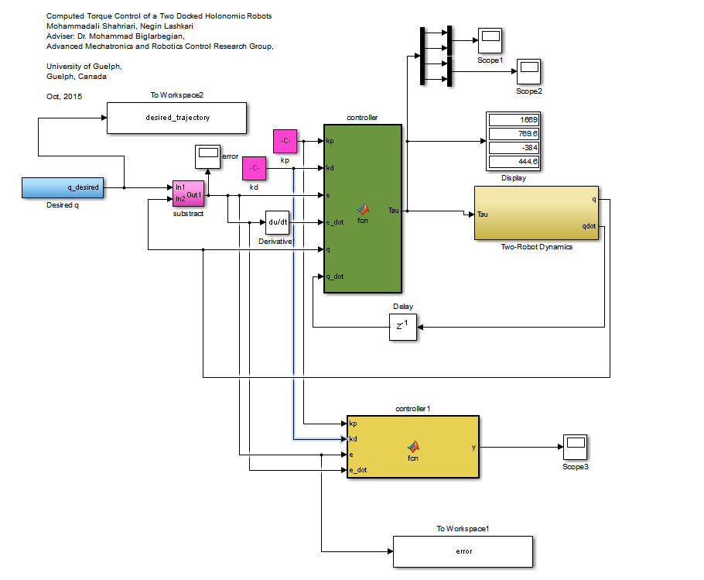



**Case 1:** For a 5th order polynomial function:

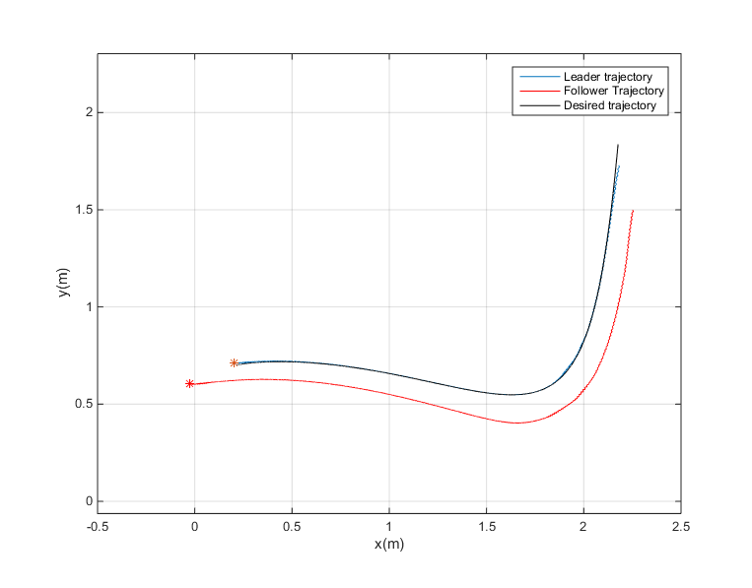

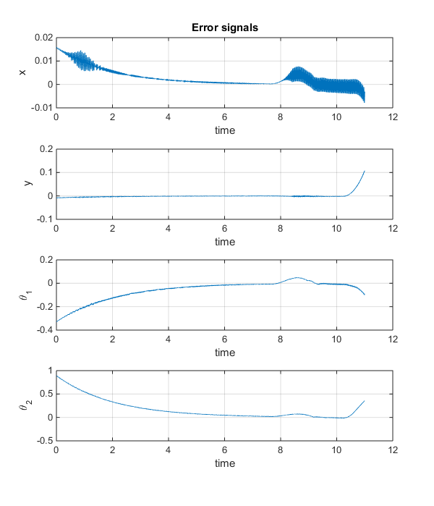

$$k_{p}=[1. 0 0 0;0 1. 0 0 ; 0 0 0.01 0; 0 0 0 0.01]*10$$

$$k_{d}=[1 0 0 0;0 1 0 0 ; 0 0 0.01 0; 0 0 0 0.01]*20$$

***Integration initial condition:*** [0.2;0.71;pi/6;pi/9;0;0;0;0]

***Upper saturation limit:*** [inf,inf,inf,inf,2,2,2,2]*0.3

***Lower saturation limit:*** -[inf,inf,inf,inf,2,2,2,2]*0.3

For a 3rd order polynomial function: